**­CSC 1101 – Problem Solving and Programming Laboratory – Winter 2019**

**Lab 15 – Trevor Trusty**

**25 points – Due March 19, end-of-class**

**a)** Save this document with your name and the lab assignment number somewhere in the file name.

**b)** Type/paste your answers into the document.

c) Submit this document and your .cpp file(s) to the Canvas item where you downloaded this document. Do not submit a zip file but individually attach your files.

Using your code from Take Home Lab 14, write a C++ console application and do the following:

1. Rename the lab to **yourName_InClass_Lab15.cpp** and save it into your *CSC1101* folder.
2. Complete the header comment and modify the application header and close to contain the application name.
3. Declare a real valued variable **pi** to store your approximation to Pi as well as a variable for the number of terms that will be used to approximate **pi***.*
4. Create a real valued function called **piApproximation** that takes an **integer** as input (parameter) and returns the approximation to Pi.
5. In the main function, use a **for** or **while** loop to prompt the user for an integer value greater than or equal to 1 three times. Validate the user input as well.
6. In the loop, call function **pi** using the integer as the argument. Make sure you store this returned value into the real valued variable **pi**.
7. Print the input and pi-approximation. Format it to look like the sample output.
8. Approximate to 16 digits and take a screenshot of the whole output.

Sample Output

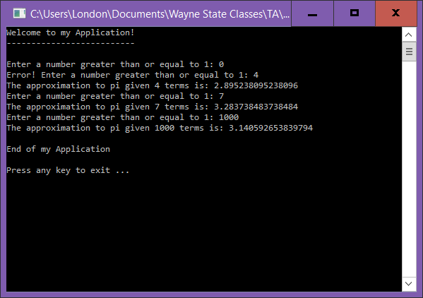

*[your program code here]\**

**//==========================================================**

**//**

**// Title: PI Approximator**

**// Course: CSC 1101**

**// Lab Number: Lab 15**

**// Author: Trevor Trusty**

**// Date: 3/19/2019**

**// Description:**

**// Takes number of terms from the user to approximate PI with**

**// using Leibniz formula.**

**//==========================================================**

**#include <conio.h> // For function getch()**

**#include <cstdlib> // For several general-purpose functions**

**#include <fstream> // For file handling**

**#include <iomanip> // For formatted output**

**#include <iostream> // For cin, cout, and system**

**#include <string> // For string data type**

**using namespace std; // So "std::cout" may be abbreviated to "cout"**

**//Function Prototypes**

**bool iseven(int); // Call iseven() to test if integer is even**

**double piApproximation(int);**

**int main()**

**{**

**// Declare variables**

**int d; // Number of digits to approximate**

**double x = 1; // Denominator's value**

**double run = 0; // The result of each loop**

**// Show application header**

**cout << "Welcome to PI Throwers!" << endl;**

**cout << "--------------------------" << endl << endl;**

**for (int i = 1; i <= 3; i++) //Approximating pi 3 times**

**{**

**// Read from console**

**cout << "Enter the amount of digits to approximate pi to, that is at least 1: ";**

**cin >> d;**

**while (d < 1) //Validating user input**

**{**

**cout << "Catastrophic Failure: response must be at least 1, you entered " << d << '.';**

**cout << "\n\nEnter the amount of digits to approximate pi to, that is at least 1: ";**

**cin >> d;**

**}**

**// Write to screen**

**cout << setprecision(16);**

**cout << "Approximation:\t" << piApproximation(d) << endl;**

**}**

**// Show application close**

**cout << "\nEnd of PI Throwers" << endl << endl;**

**// Pause before application window closes**

**cout << "Press any key to exit ..." << endl;**

**_getch();**

**return 0;**

**}**

**//function definitions**

**bool iseven(int v) // Call iseven() to test if integer is even**

**{**

**if (v % 2 == 0)**

**{**

**return true; // Integer is even**

**}**

**else**

**return false; // Integer is odd**

**}**

**double piApproximation (int x) // User input (int)**

**{**

**double y = 0; //Pi approximation**

**double z = 1; // Denominator**

**for (int i = 1; i <= x; i++)**

**{**

**if (iseven(i)) // loop counter is even**

**{**

**y -= 1 / z; // y is the approximation of pi**

**z += 2;**

**}**

**else //loop counter is odd**

**{**

**y += 1 / z;**

**z += 2;**

**}**

**}**

**y *= 4;**

**return y;**

**}**

*[your program output here]\*\**

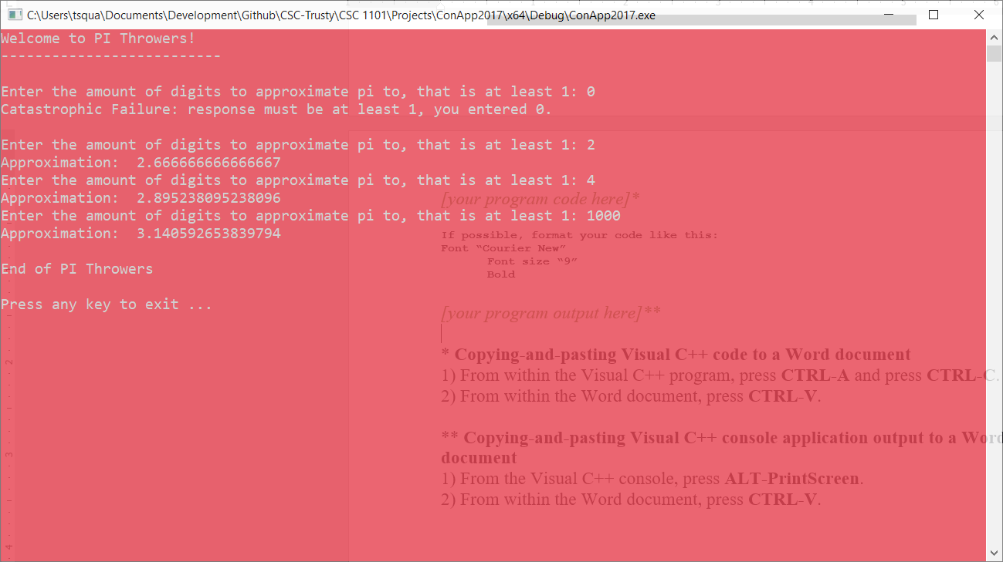

* **Copying-and-pasting Visual C++ code to a Word document**

1) From within the Visual C++ program, press **CTRL-A** and press **CTRL-C**.

2) From within the Word document, press **CTRL-V**.

** **Copying-and-pasting Visual C++ console application output to a Word document**

1) From the Visual C++ console, press **ALT-PrintScreen**.

2) From within the Word document, press **CTRL-V**.